**Karan Arora** **R.L. Institute M: 9416974837**

**Max Time : 1 hr** **Class : 12th Chemistry Max Marks : 25**

**Amines**

1. Multiple choice Questions: [ 1 x 10 = 10 ]
2. Amongst the following the strongest base in aqueous medium is :

|  |  |  |  |
| --- | --- | --- | --- |
| a) CH3NH2 | b) NCCH2NH2 | c) (CH3)2 NH | d) C6H5NHCH3 |

1. Which of the following is the weakest Bronsted base?

|  |  |  |  |
| --- | --- | --- | --- |
| a) | b) | c) | d) CH3NH2 |

1. The correct increasing order of basic strength for the following compounds is:

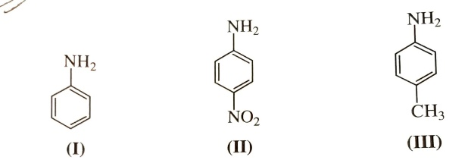

|  |  |  |  |
| --- | --- | --- | --- |
| a) II < III < I | b) III < I < II | c) III < II < I | d) II < I < III |

1. Which of the following has highest pKb value?

|  |  |  |  |
| --- | --- | --- | --- |
| a) CH3CH2NH2 | b) NH3 | c) CH3NH2 | d) C6H5NH2 |

1. The order of reactivity of halides with amines is :

|  |  |  |  |
| --- | --- | --- | --- |
| a) RBr > RI > RCl | b) RI > RBr > RCl | c) RCl > RBr > RI | d) RI > RCl > RBr |

1. Carbylamine reaction is used as a test for :

|  |  |
| --- | --- |
| a) Primary amines | b) Secondary amines |
| c) Primary and secondary amines | d) Secondary and tertiary amines |

1. Which of the following compounds will dissolve in an alkali solution after it undergoes reaction with Hinsberg’s reagent?

|  |  |  |  |
| --- | --- | --- | --- |
| a) (CH3)3 N | b) CH3NH2 | c) (C2H5)2 NH | d) C6H5NHC6H5 |

1. Methylamine reacts with HNO2 to form:

|  |  |  |  |
| --- | --- | --- | --- |
| a) CH3 – O – N O | b) CH3 – O – CH3 | c) CH3OH | d) CH3CHO |

1. Reduction of nitrobenzene by which of the following reagent gives aniline?

|  |  |  |  |
| --- | --- | --- | --- |
| a) Sn/HCl | b) Fe/HCl | c) H2 – Pd | d) Sn/NH4OH |

1. Which of the following cannot be prepared by Sandmeyer’s reaction?

|  |  |  |  |
| --- | --- | --- | --- |
| a) Chlorobenzene | b) Bromobenzene | c) Iodobenzene | d) Fluorobenzene |

1. Arrange the following in increasing order of basic strength : [ 2 ]

(i) C6H5NH2  , C6H5N(CH3)2 , (C2H5)2 NH , CH3NH2. (ii) Aniline , p-nitroaniline , p-toluidine

1. How would you convert : [ 2 ]

(a) Ethanoic acid to Propanoic acid (b) Methanol to Ethanoic acid

1. Give the structure of A , B and C in the following reactions : [ 3 ]
   1. C6H5NO2 A B C
   2. CH3COOH A B C
   3. C6H5NO2 A B C
2. Why cannot aromatic primary amines be prepared by Gabriel phthalimide synthesis? [ 3 ]
3. Accomplished the following conversions : [ 1 x 5 = 5 ]

(a) Nitrobenzene to Benzoic acid (b) Aniline to 2, 4, 6-tribromofluorobenzene (c) Aniline to p-bromoaniline

(d) Aniline to Benzyl alcohol (e) Chlorobenzene to p-chloroaniline